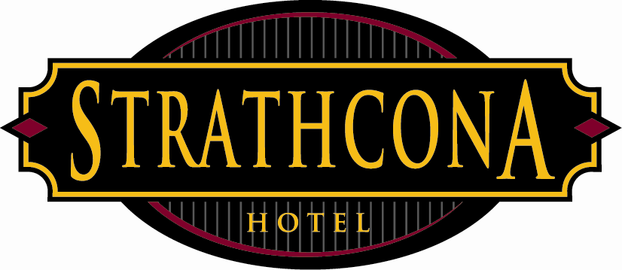
Strathcona Hotel
Policies & Procedures

Subject: Return to Work Policy
Effective Date: January 15, 2008

Policy:
Return to work program is designed to promote return to work following injury and to minimize the physical, financial and social impact encountered by injured workers. If you have been injured and received clearance from your doctor to return to work in a modified position, your department manager and the director of human resources will ensure that you are offered a suitable position. You must ask your doctor to specifically state your work restrictions. It is advised that you contact the department manager and or the director of human resources immediately following your doctor’s appointment. Failure to do so may jeopardize further compensation from WCB.

- Strathcona Hotel undertakes to provide meaningful employment for temporarily disabled employees.

- Strathcona requests that the employee reports the injury immediately to the immediate supervisor so that the appropriate documentation can be processed such as an accident report.

- Strathcona will design a temporary modified work program for all temporarily disabled employees.

- Strathcona asks that the disabled employee agree to accept the modified work program designed, provided the duties expected to be completed meet the specifications determined by a professional medical practitioner or the applicable workers compensation’s suggested standard restrictions.

