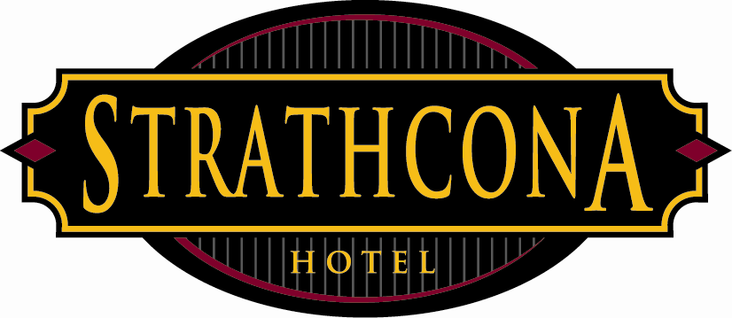
Strathcona Hotel
Policies & Procedures

Subject: Ejection Policy
Date: January 6, 2014

It is often the case that security personnel must ask (eject) patrons from the Strathcona Hotel for intoxication. This policy is to ensure that the patrons of the Strathcona Hotel are met with a high level of care, despite their mental and physical state at the time of the ejections.

Security personnel should follow these steps when asking a patron to leave.

1) Identify the intoxicated individual and call for back up on the radio. Always have a witness/back up in case the ejection needs to go physical.

2) Identify yourself as hotel security and an employee of the Strathcona Hotel. Inform the person in question politely that they are being asked to leave for the evening.

3) Ask the person if they have a jacket or items (coat check ticket) and if they are with anyone (a friend or group of friends). If they have a coat check ticket, ask for it and have another team member retrieve the item. Walk the person to the closest unobstructed exit.

4) Ask the person again if they have friends with them so they can be informed of the ejection. Ask the patron if they have a tab running at one of the bars. If they do, that tab needs to be settled up. Due to the state of intoxication, ejections will require patience.

5) Have a team member seek out the ejected patron’s friend(s) after they have been escorted out the door. Tell the friends that ‘your friend is outside (location) and was asked to leave for the evening for intoxication. We are informing you so you know where they are.”

6) Avoid having intoxicated patrons wander around the bar looking for friends or lost items. This typically takes up time and the sober security personnel can usually do the job much faster.

7) As the ejected patron “ Can we please get you a taxi cab for the evening? We’d like you to get home safe.” Some patron’s will be very appreciative for this gesture. Others will refuse.

8) Make sure that all ejected patrons are in a state that they won’t fall over while outside our establishment. If they are having trouble standing, try and get them to sit down. It is at this time that other security are hopefully able to located friends and have them take over the situation and get their friends home safely.

9) Taxi cabs will often refuse very intoxication persons. If this is the case and you cannot find a friend, you may need to call the non-emergency line of the Victoria Police and tell them “you have a very intoxicated person outside the Strathcona Hotel who needs assistance.” The police will send a unit around to investigate.

10) If a patron is injured outside the Strathcona Hotel, and it is safe to do so, render first aide and call 9-11 immediately.

This policy is in place to protect both the patron and the Strathcona Hotel and show that employees are doing their due diligence in regards to intoxicated patrons.

Please note that this policy does not include highly aggressive or non-cooperative combative patrons. In such cases, a call to the Victoria Police may be necessary.

