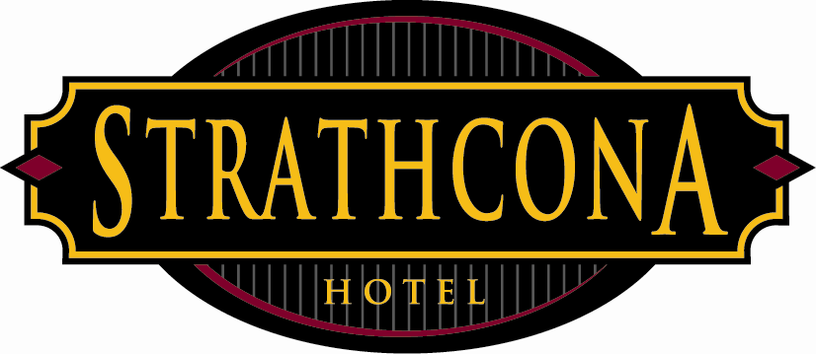
Strathcona Hotel
Policies & Procedures

Subject: Hearing Protection
Date: March 21, 2013

The Strathcona Hotel Victoria would like to emphasis the importance of the strict adherence of all rules and regulations pertaining to noise exposure/working in a loud environment in accordance with the guidelines set by Worker’s Compensation Board.

When working in a loud environment you should always wear hearing protection. All staff working in our nightclubs must use hearing protection at all times when a live band/performer and or DJ is playing.

Hearing protection is available at the hotel front desk, Club919 bottom cover booth, Club919 Fire bar, or from a duty manager.

At the Strathcona Hotel we take noise measurements (db levels) on a regular basis to ensure we are in accordance with WCB standards. We also provide an annual hearing test at no cost to employees and information is posted on our staff website, handbook, bulletin board and on posters to indicate noise hazard areas.

I, ____________________________ understand the information above and understand that hearing protection is to be worn when working in a loud environment. I also acknowledge that the Strathcona Hotel has taken the necessary preventative measures to ensure the safety of its employees regarding noise exposure.

________________________________________ ___ __________________
Signature Date
By signing you acknowledge the Strathcona Hotel’s
policy on noise exposure

