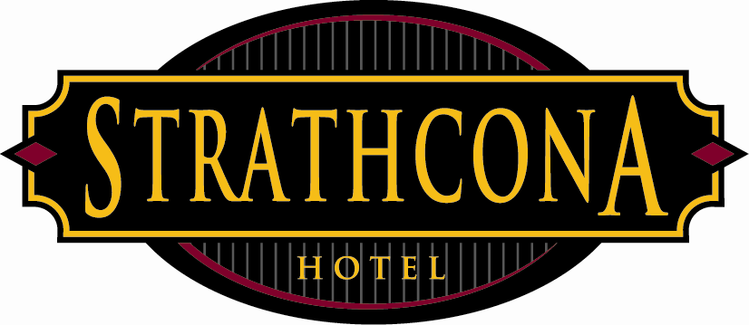
Strathcona Hotel
Policies & Procedures

Subject: Lost Name tags
Revised: February 20, 2013

This memo is to notify management and staff that are required to wear a nametag while at work that there will be a charge if you lose and require a new name tag. The charge will $5.00 and will be deducted from your staff account.
All management and staff with exception of LRS, Security and Kitchen are required to wear a name tag. After 8pm it is ONLY optional for our front of the house staff (bartenders, servers, food runners, hosts, bar backs, houseman & porters).

Any manager or staff member that requires a nametag shall put their name on the list provided on the HR bulletin board in the staff room. Turnaround time is one to two business days.

Wearing a nametag is part of our dress code policy and is not optional and as such can be cause for disciplinary actions.

