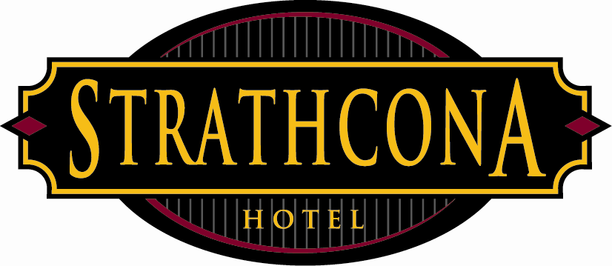
Strathcona Hotel
Policies & Procedures

Subject: No smoking policy
Revised: February 21, 2013

This policy have been revised to ensure that all employees have solid knowledge regarding the no smoking policy in British Columbia and our responsibilities as a staff member, manager and / or owner to ensure compliance.

As of March 31, 2008 new tobacco laws came into effect in British Columbia and as such all indoor work and public places must be smoke-free. Designated smoking rooms will not be allowed in bars, restaurants, casinos and bingo halls. Smoking will not be allowed within three meters of most public and workplace doorways, open windows or air intakes.

To ensure compliance all indoor areas have since been non-smoking areas including our Rooftop Patio. All ashtrays both indoors and outdoors have been removed and no smoking signs have been strategically placed throughout the building. We have also painted no smoking lines outside of our main entrances and exits.

All staff must be aware that if a patron decides to smoke within the three (3) meter of our door ways it is our responsibility to tell the patron to please stop smoking or move away from the buffer zone of 3 meters. All employees are to follow these simple steps:
- Approach the patron and politely ask he/she to stop smoking or move further away from the door way.
- Remind the patron that both the Strathcona and the patron can be fined for breaking the law.
- If the patron does not comply contact your duty manager and or senior manager on duty
- Duty Manager or senior manager will then approach the patron to repeat the request. If the patron does not comply they will not be allowed on the premises.
- Duty Managers are to record the incident in the managers log book.

