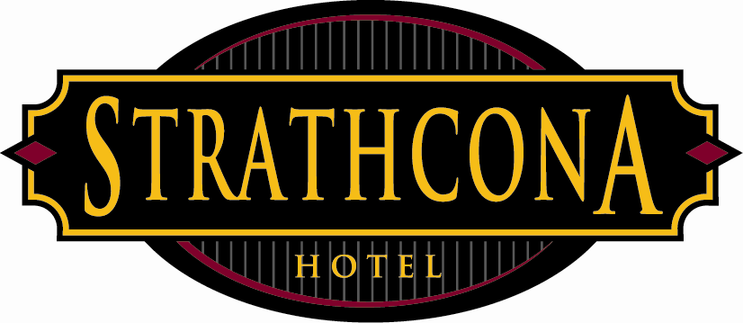

Strathcona Hotel
Policies & Procedures

Subject: Smoking while on duty – FOH staff
Revised: May 3, 2013

This policy is being implemented to ensure quality service towards our guests as well as promoting fairness amongst staff in the amount of breaks that are taken during a shift.

Effective immediately staff will only be allowed 3 smoke breaks per shift. If you are working as a server, support staff or bartender then those breaks must be taken when not so busy.

No smoke breaks can be taken during lunch or dinner service as well as late night, these are the hours:
Noon – 2pm & 6pm – 8pm or during the very busy 11pm – 2:00am

To ensure compliance with the laws of BC smoking must be away from doors and air intake at least 3meters. Smoking is only allowed in the back alley.

Failure to comply with this policy will be cause for progressive discipline.

