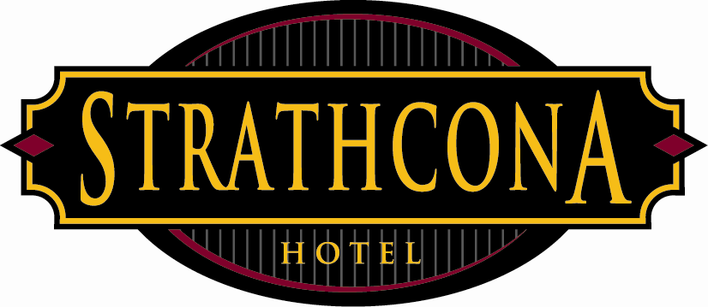

Strathcona Hotel
Policies & Procedures

Subject: Front of house tip pool
Date: April 15, 2013
REVISED June 22, 2017

See below changes highlighted in yellow.

These updated changes are in an effort to keep up with industry standards, and to help the overall service of our patrons by strengthening our support systems. An improved overall guest experience will mutually benefit all front of the house employees.

This policy will affect the following outlets: Rooftop, Maple room, Sticky Wicket, Games room, Clubhouse, and Distrikt. This policy will not include Big Bad John’s as it already has a functional tip out system in place.

SW/ROOFTOP/GAMESROOM/CLUBHOUSE &MAPLEROOM
Servers:
2.5% of LIQUOR sales directly to the bartender (as present)

2.5% of FOOD sales to the tip pool (as present)
2.0% of total sales to the tip pool. IF YOU WORK A DAY TIME SHIFT THIS PERCENTAGE IS 1.5%
4.5% total percentage. (Daytime 4%)

Bartenders:
2% of total sales to the tip pool. IF YOU WORK A DAY TIME SHIFT THIS PERCENTAGE IS 1.5%
Does NOT include house charges, keno, staff meals & promo charges.

Distrikt BARS
2% of total sales to the tip pool. *Distrikt has their own support staff and has a mandatory 1% tip out of their total sales to that support team. (Does not include beer tub or shooter bar).

Who is included in the tip pool?

Housemen, Food runners, Hosts, Kitchen staff, Doormen, and Duty Managers.

*A higher percentage will be given to food runners/hosts based on the business volume of shifts worked. I.e. a host/runner on a Friday night will receive a higher percent from the tip pool than a host/runner on a Monday day shift.

The Duty Managers are now included in our tip pool in order to keep up with industry standards.

If you have any questions or are seeking clarification about the new policy please email Terry – terry@strathconahotel.com or Brock – brock.olson@strathconahotel.com.

