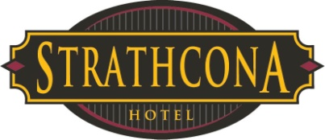

Memo: To FOH Employees
From: Human Resources
Revised: May 8, 2014
Revised: April 18, 2018

Regarding: Memo, Time off requests FOH

We are entering our high season. Please be aware we will not be allowing any extended leaves or time off from May through September.

Do not take for granted that when you hand in a time off request it will be approved. We remind you to not make any travel arrangements and/or buy concert tickets prior to approval.

Do not rely on having a set schedule week to week. Always check your schedule. Your schedule is subject to change especially during our busy summer season.

Reminder when picking up shifts or switching shifts you cannot work over 40 hours a week.

There are a few weekends during the summer when many staff members will try to take time eg. big concert weekends. Our decision in who gets the time off will be based on: business levels, seniority, time of request, and how many other requests you have had approved during the summer. We will be limiting the number of staff per department that can be off at the same time i.e. no more than 3 servers during the same time period. Even though there may only be one weekend all summer that you are requesting you need to be prepared not to get it off.

We will contact you at least 2 weeks prior to your requested time off to let you know if it’s approved or not. HOWEVER at times our decision will be last minute when creating the schedule as business levels can change very quickly in this industry.

We always strive to accommodate all requests but please understand that sometimes this is impossible. In general do not count on taking Fri-Sun off during the summer!

May long weekend, Canada Day, B.C Day and Labour Day are all weekends where we need all hands on deck!

Any questions contact HR directly.

